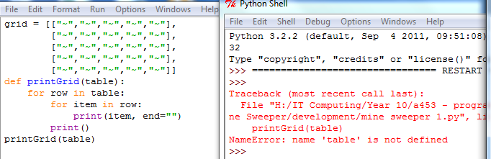Mine Sweeper

As you can see in the above screenshot, my first error I came across is “name ‘table’ is not defined”, to fix this error I changed “printGrid(table)” to ”printGrid(grid)” this defined grid and allowed the grid to be printed.

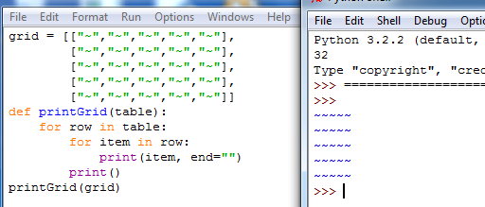Here is a screenshot of the fixed code.

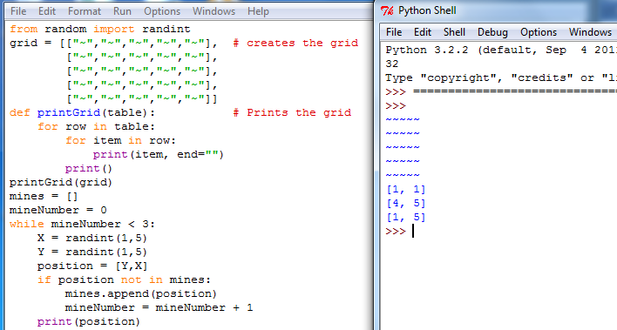

in this screenshot I have added in the code for the mines. 3 random mines are created.

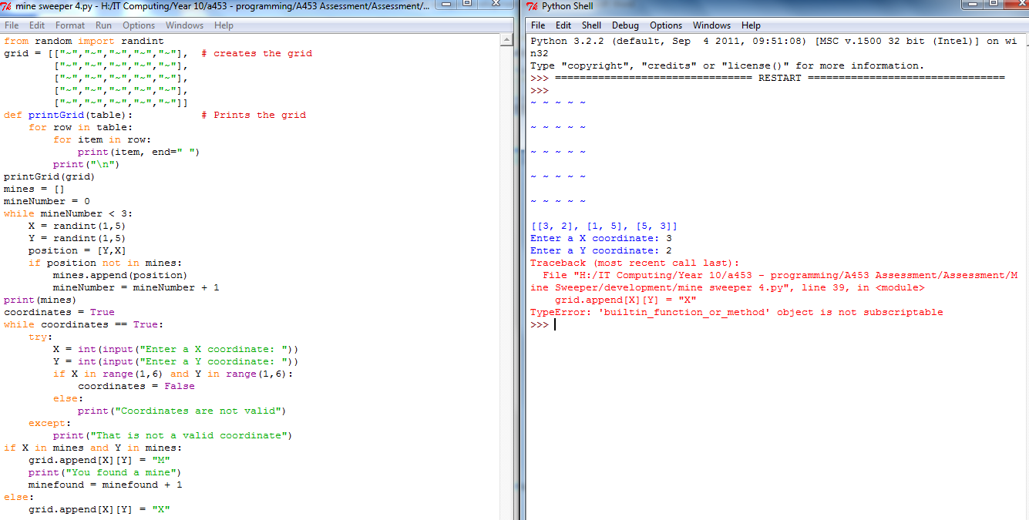In the above screenshot I have added in, the code that asks the user to enter coordinates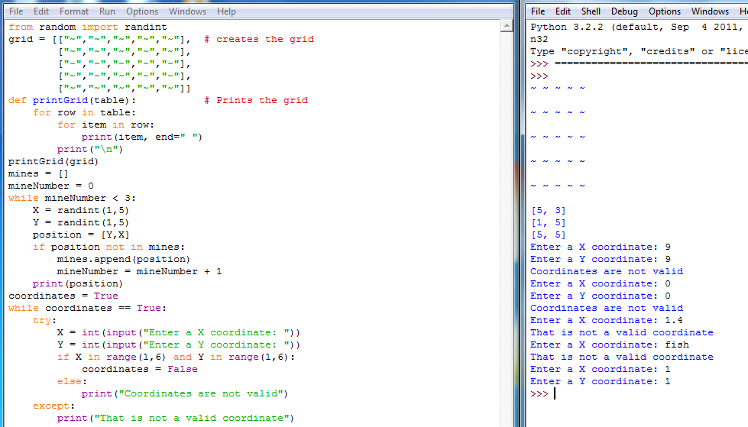, and then validates where it is a valid coordinate or not.

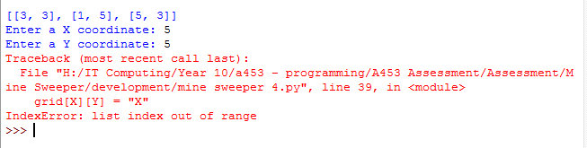I added in the code that checks, if the coordinates the user entered is a mine. I came across the error “object is not subscriptable” to fix this error I changed “grid.append[X][Y] = "X"” to “grid[X][Y] = "X"”

I then got this error “list index out of range”. to fix it I changed “grid[X][Y] = "X"” to “grid[X-1][Y-1] = "X"”

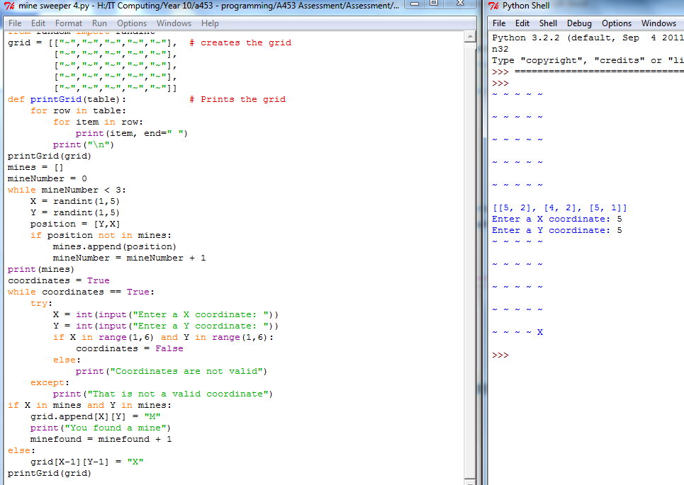

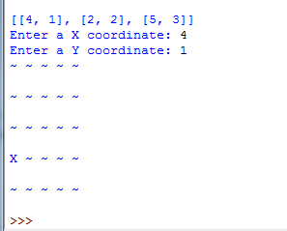In the above screenshot is the fixed code; as you can see in the python shell, the code has successfully updated the grid with the users coordinates.

But as you can see in the screenshot to the left, when you enter the position of a mine it should print “You found a mine!” and upgrade the grid with the mines position, but it does not do any of this.

Testing table

|  |  |  |  |
| --- | --- | --- | --- |
| X coordinate input | Y coordinate input | Output | Screenshot |
| 0 | 0 | Error message |  |
| 1 | 1 | Updated grid correctly |  |
| 6 | 2 | Error message “Coordinates are not valid” |  |
| “one” | “two” | Error message “That is not a valid coordinate” |  |
| 1 | “five” | Error message “That is not a valid coordinate” |  |
| 2.5 | 2 | Error message “That is not a valid coordinate” |  |
| 5.7 | 1.2 | Error message “That is not a valid coordinate” |  |
| X position of mine | Y position of mine | Update grid with mine |  |
| Enter an X and Y coordinate you have already entered. | | Outputs “you have already enter this coordinate” |  |

Complete code:

